12D Library Synchronization
Brisbane Office

27 November 2017
Rev00
Prepared for:

Client representative:

Date:
Table of Contents

Executive Summary i

1. Introduction 1
1.1 How it works 1
1.2 Glossary 1
1.3 Looking ahead 1
2. Installation 1
3. LibSync Macro 2
3.1 Launching the macro 2
3.2 Selecting the client domain and library version 2
3.3 Saving the 12D environment 3
3.4 Launching the LibrarySync application 3
3.5 Finishing the macro 3
4. LibSync Application 3
4.1 Command line arguments 3
4.2 Selecting files and folders to sync 4
4.3 Reviewing the file list 4
4.4 Copying the files 4
4.5 Two-way synchronization 5
5. Launching the macro from the 12D toolbar 5
6. Maintenance of updated libraries 5

List of figures
No table of figures entries found.

List of tables
No table of figures entries found.

Appendices
Appendix A:
Appendix B:
Appendix C:

Prepared by: ……M. Jensen……………………………. Date: 27 November 2017
Name

Reviewed by: …………………………………………………. Date: 6 January 2016
Name

Authorised by: …………………………………………………. Date: 6 January 2016
Name

Revision History
Rev No. | Description | Prepared by | Reviewed by | Authorised by | Date

© 2017 pitt&sherry
This document is and shall remain the property of pitt&sherry. The document may only be used for the purposes for which it was commissioned and in accordance with the Terms of Engagement for the commission. Unauthorised use of this document in any form is prohibited.

Summary
The 12D library synchronization system has been created to allow each Pitt & Sherry project to adopt a different User Library and Customer Library for each Pitt & Sherry project. The system creates a copy of files located in a master library down to the Synergy 12DModel folder adjacent to the 12D projects. It also manages the 12D environment variables which point to the mirrored libraries.

Introduction
The 12D library synchronization system has been created to allow each Pitt & Sherry project to adopt a different User Library and Customer Library for each Pitt & Sherry project. The system creates a copy of files located in a master library down to the Synergy 12DModel folder adjacent to the 12D projects. It also manages the 12D environment variables which point to the mirrored libraries.

How it works
The Library Synchronisation package consists of two parts, A 12DML macro, and a windows desktop application.

The LibrarySync 12DML macro is launched when a new project is created. This macro allows the user to select the preferred client domain for the new project and sets the 12D User_Lib and Customer_Lib environment variables based on the user’s selections. The macro also launches the windows desktop application and passes the relevant information to that application using command line arguments.

The LibrarySync desktop application manages the synchronising of the master user library and customer domain with the local user library in the synergy job.

Glossary
Pitt & Sherry project: This refers to the project generally held in Synergy which houses documents.
12D project folder: The synergy managed folder (including the 12D working folder)
Master Library: The main repository of 12d Uer Library files. (Currently on O: drive.)
Local Library: A replica of the master library located at the same folder level as the 12D Project.
Client Domain: The collection of user files and string naming conventions specific to a Client.

Looking ahead
As this is the first release of this system it may go through an evolutionary process to refine its functionality. Any bugs or enhancements may be suggested to facilitate its development.

Installation
The Pitt & Sherry 12D Library Synchronization system can be installed by copying five files to your default User and User_Lib folders. The files are sourced from the master library on O: drive. (O:\12D\User_Lib_Master)

The files to copy are…
- macros.4d: Copy to C:\12d\11.0\User
- project_macros.4d: Copy to C:\12d\11.0\User
- Folder.bmp: Copy to C:\12d\11.0\User_Lib
- PSLOGO75x75.bmp: Copy to C:\12d\11.0\User_Lib
- User.toolbars Copy to C:\12d\11.0\User_Lib
The files perform the following functions…

Macros.4d
The macros.4d file contains a list of macros which are run automatically each time a new 12D project is created. The macro.4d will be ignored when an existing 12D project is opened. The file contains a pointer to the LibrarySync.4do file in the master_library on O: drive.

project_macros.4d
The project_macros.4d file contains a list of macros which are run automatically each time an existing 12D project is created. The file contains a pointer to the LibrarySync.4do file in the master_library on O: drive.

User.toolbars
The User.toolbars file contains a button which will launch the LinkSys macro within an existing 12D project. This allows the macro to be manually executed after the first time it has been run in a project.

Folder.bmp & PSOGO75x75.bmp
These two files are required for presentation on the toolbar and macro panel. If these files are missing the program will operate normally however some buttons and logos will not appear correctly.

LibSync Macro

Launching the macro
The macro will run automatically when a new project is opened. When an existing project is opened, the macro can be run from the toolbar provided.

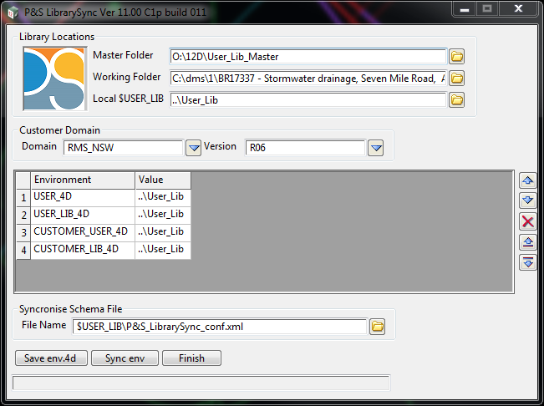

Selecting the client domain and library version
The user can select the required Customer Domain and library version from the drop-down list. This in then enters the required environment variables into the table as shown.

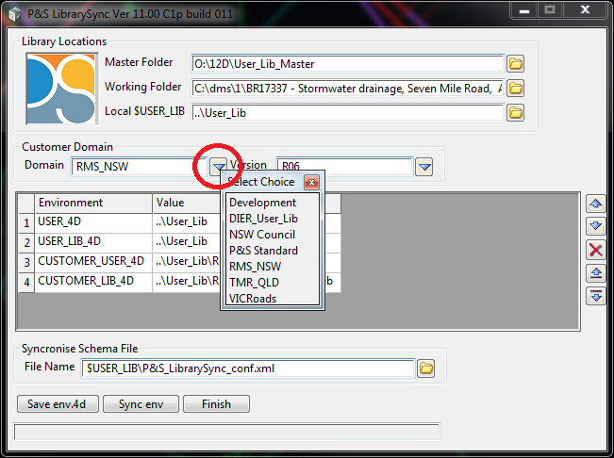

Saving the 12D environment
Clicking the button will create an env.4d file in the 12D projects working directory. The respective environment variables will be appended to the end of this file. The new environment variables will not be applied until the project is restarted. This can be done from the Project->restart menu option.

Launching the LibrarySync application
Clicking the button will launch the LibrarySync desktop application and pass the master folder and local $User_lib folder to the application as command line arguments.

Finishing the macro
Pressing the button will close the macro. When the macro is closed the project’s environment metadata will be saved to the project attributes and an XML file (P&S_LibrarySync_conf.xml) is written to the project’s current User_Lib folder. Once the environment attributes are set the macro will not run automatically. It can be launched with the toolbar.

LibSync Application

Command line arguments
The LibSync macro takes two command line arguments when it is launched. If these are omitted, then the Master folder and Local folders must be set when the application is run.
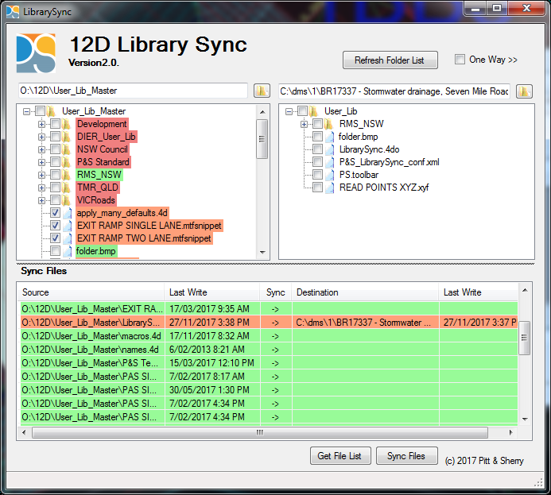

Selecting files and folders to sync
The presents two folder tree structures at the top of the panel. The tree on left shows folders and files in the Master Library folder and the tree on the right shows folders in the Synergy Local Library folder. Selecting the yellow folders at the top of the lists will allow the root folder of each tree to be amended. Usually is should not be necessary to change the root folder.

The checkboxes beside a folder item in the tree can be used to select or unselect all files or folders below that folder.

The checkboxes beside each file item can be used to select or unselect that file.

Files and folders in the Development folder will not be copied.

Reviewing the file list
Pressing the button will load the selected folders into the Sync files table for perusal before the synchronisation takes place.

Copying the files
Pressing the button will perform the file synchronisation copying the files listed in the Sync files table.

Two-way synchronization
Checking the checkbox will toggle the application from one-way synchronisation to two-way synchronisation. Usually only 12D administrators will perform this operation. The two way operation allows the ongoing development of the 12D Libraries in Live projects.

Launching the macro from the 12D toolbar
The P&S toolbar can be enabled by entering the View->toolbars menu option. The toolbar contains at least one button which launches the LibrarySync 12DML macro.



Maintenance of updated libraries

The user should regularly launch the LibrarySync application from within 12D to update the project’s local User Libraries.

Contact
Michael Jensen
(07) 3058 7406
mjensen@pittsh.com.au

